  - Overview

CHAPTER-6
TESTING
Testing is a critical component in the software development lifecycle, aimed at identifying and resolving errors to ensure that the system meets its in- tended requirements. For the Leaf Village, testing was performed to verify functional accuracy, performance, and overall reliability.
This chapter covers the testing methodologies, techniques used, test cases designed, and results obtained during the testing phase.

Testing Methods
The testing process incorporated two widely used methodologies:

Black-box Testing
Black-box testing focuses on verifying that the system operates as intended without examining its internal structures or logic. This type of testing en- sures:
      - Proper handling of user inputs.
      - Accurate generation of expected outputs.
      - Integrity of data stored and retrieved from the database.
      - Smooth interaction between different modules.

White-box Testing
White-box testing examines the internal workings of the system. It evaluates the implementation logic and ensures:
      - All paths within the system are executed at least once.
      - Logical conditions are verified for both true and false outcomes.
      - Loops are tested to ensure they function correctly under defined boundaries and conditions.
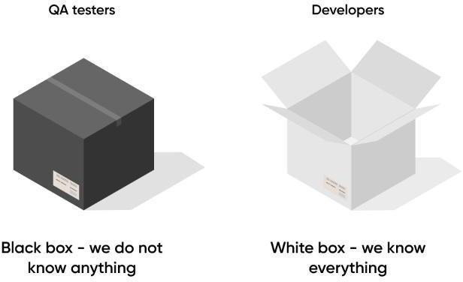

[Figure 19: Testing]

Testing Techniques Used
To ensure the app worked as expected, we applied the following testing tech- niques:
- Unit Testing – We tested individual components like login, signup, payment processing, and product upload to ensure they functioned correctly on their own.
- Integration Testing – We verified that different modules (like Hash Password, payment processing, and image storage) worked smoothly together.
- UI Testing – We manually checked buttons, navigation, and layouts to con- firm a good user experience across different web pages.
- Performance Testing – We observed website load times and tested how it han- dled multiple requests simultaneously.
- Error Handling Testing – We intentionally caused failures (e.g., network disconnection during payment or product upload) to check if the app displayed proper error messages.
- Real Device Testing – We ran the website on a physical windows device to
check real-world usability.
Tools Used:
  - Visual Studio Code (VS Code) – Code editor for writing and managing the website's code.
  - Flask – Web framework for building the website.
  - MySQL – Database for storing product details and user information.
  - Razorpay – Payment gateway integration for secure transactions.
  - HTML, CSS, JavaScript– For front-end development.

Test Cases and Execution
Detailed test cases were designed to cover all aspects of the system’s func- tionality. Below are examples of test cases:
Test Case 1: User Signup
- Description: Verify that a new user can successfully sign up.
- Input: Unique email, username, and password.
- Expected Output: Account created successfully.
- Actual Output: Account created successfully.
- Status: ⬛ Passed
Test Case 2: User Login
- Description: Verify that a registered user can log in.
- Input: Correct email and password.
- Expected Output: User is logged in and redirected to the dash- board.
- Actual Output: User is logged in and redirected to the dashboard.
- Status: ⬛ Passed
Test Case 3: Payment
- Description: Verify that a payment is processed successfully.
- Input: Valid payment details through Razorpay.
- Expected Output: Payment is processed, and details are stored.
- Actual Output: Payment is processed, and details are stored.
- Status: ⬛ Passed
Test Case 4: Adding product
- Description: Verify that subadmin can add new product with no error.
- Input: product details like name, price, image etc
- Expected Output: Product is added successfully in database
- Actual Output: Product is added successfully in database
- Status:⬛ Passed
Test Case 5: Edit Product
- Description: Verifying that the subadmin can edit the details of the product
- Input: Edited product details
- Expected Output: The edited data of the product is overwritten in the place of existing data
- Actual Output: The edited data of the product is overwritten in the place of existing data
- Status:⬛ Passed

Results and Observations
The testing process revealed the following outcomes:
- Account Management: New user can register or the old user can login with their credentials and the account details can be edited
- Payment Processing: Product purchase payments is handled through the Razorpay payment gateway without any major issues user can pay for it via various methods
- Product Management: Sub-Admin can Add new products or edit the existing ones seamlessly via their dashboard
- Admin Supervision: The Head-Admin (Super-Admin) can overview the activities going on in the website via the dashboard provided the user and Sub-Admin logins and order tracking are possible
- Minor inconsistencies in UI elements may occur and data loading and storing may take some time based on connectivity strength of the user .

Challenges Encountered
During the testing process, the following challenges were faced:

- Storing Order history: We face an issue of retrieving the order history from the Razorpay dashboard after the purchase was a success as the API was a new ground for use
- UI inconsistencies: As our web was not as responsive as it should have been we faced a challenge to set the elements of the website properly on different device and screen size with various adjustments
- Latency: As the data query is sent to the database executed and then the output is give some tasks took longer than expected to respond to the user input

CONCLUSION
It was a great experience to design and implement the Leaf-Village (Plants and Greenery website) by using Python and to work on its documentation. While working on this project we have learned many things especially how to apply the concept of Python in modelling of real world systems. This project is developed using Python, HTML, CSS, JavaScript and MySQL fully meets the objective of the system which it has been developed. This project is used for easy buying of plants and its tools to maintain and grow various types of herbs. The website allows you to buy plants, tools etc. The website also provides you with a small manual of how to grow and maintain plants, which separates this website from the others.

BIBLIOGRAPHY

  - Book Reference
- Python crash course, Second Edition Author: Eric Matthes Published by: No Starch Press in 2019.
- Javascript: The Definitive Guide, Seventh Edition Author: David Flanagan Published by: O’Reilly Media in 2020.
- MySQL Cookbook: Solutions for Database Developers and Administrators, Fourth Edition Author: Paul DuBois Published by: O'Reilly Media in 2014.

  - Web Reference
- W3schools
Link: https://www.w3schools.com/django/django_admin.php

- W3schools
Link: https://www.w3schools.com/js/js_validation_api.asp

- W3schools
Link: https://www.w3schools.com/sql/sql_hosting.asp

